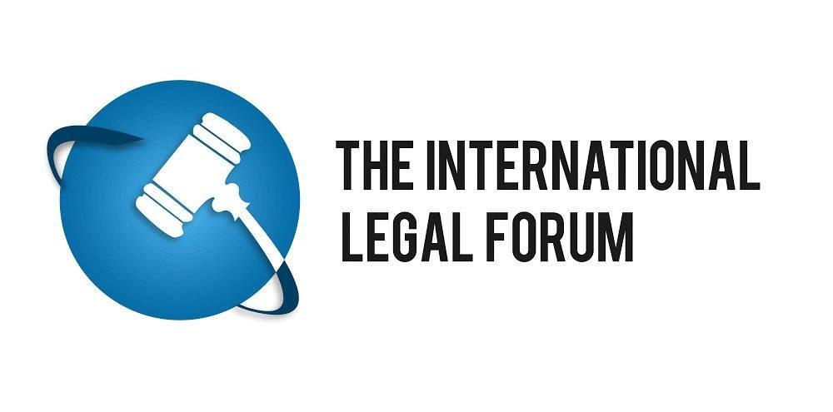

PayPal
Attn: Compliance Officer
aupviolations@paypal.com
April 15, 2020

Ref: Misuse of PayPal services by Collectif Palestina Vaincra

Dear Compliance officer,

The ILF is a non-profit, proactive legal hub, coordinating the efforts of attorneys, professional organizations and activists worldwide in their respective fights to promote justice, peace and equality in Israel and the Middle East. The ILF is ultimately dedicated to facilitating international cooperation in the global battle against radical ideologies, terror and the boycott, divestment and sanctions (BDS) movement.

We write to you in order to inform you that your PayPal services are being used by an organization called "Collectif Palestina Vaincra (CPV)". CPV is a member of "Samidoun", a proxy organization of the Popular Front for the Liberization of Palestine (PFLP). The PFLP is a designated terrorist organization in the EU, US, Canada and Israel.

CPV has a charter in which it states, amongst others:
- that Palestine should be liberated from the Mediterranean Sea to the Jordan river (thereby eliminating the State of Israel).
- that they support the armed struggle (read: terrorism) against Israel
- that they denounce France's support for Israel
- that they are a member of Samidoun
- that they support the boycott against Israel
Here you will find the link to their charter in French, directly followed by the charter in English:
The activities of CPV represent a sample of an ongoing, systemic method of operation that discriminate Israel and/or organizations engaging in commercial activity with Israel, in violation of French (criminal) law, including the “Lellouche Law” (LOI n° 2003-88 du 3 février 2003 visant à aggraver les peines punissant les infractions à caractère raciste, antisémite ou xenophobe), which explicitly provides that discrimination on the basis of any ground is prohibited and (the incitement of) discrimination on the basis of nationality is illegal.
By calling for a boycott against Israeli products and services, BDS activities may obstruct the normal exercise of the economic activity of a trader (for instance, the activity of a supermarket), in breach of the Criminal Code.
It should be further noted, that while BDS activists have the right to protest, such actions do not have to be tolerated if they disproportionately obstruct lawful business activities and prevent consumers from exercising their own social and cultural choices. In this respect, French courts have regularly condemned manifestations organized by the BDS movement at the premises of supermarkets on these grounds. See for example the decision of the French Supreme Court for Criminal Cases of 20 October 2015 (ECLI:FR:CCASS:2015:CR04290).
These public campaigns are being sponsored through crowdfunding campaigns and/or internet sales campaigns, like the current one displayed at their website. When advertising their campaign, CPV clearly state their intentions to conduct the above-mentioned illegal activities. By allowing them to use the PayPal services, you have been explicitly or implicitly aiding these organizations in conducting such illegal activity out in the open. In addition to that you are also generating material support for terrorism, considering the relation between CPV, Samidoun and the PFLP. This is further supported by the explicit mention of CPV’s support for armed struggle and the goal of annihilating Israel in the CPV charter.
The aforementioned activities are not only against the law, but also fail to comply with PayPal’s own basic requirements detailed in your ‘Restricted Activities’ section in the PayPal user agreement which reads:
“In connection with your use of our websites, your PayPal account, the PayPal services, or in the course of your interactions with PayPal, other PayPal customers, or third parties, you must not:…
…Violate any law, statute, ordinance, or regulation (for example, those governing financial services, consumer protections, unfair competition, anti-discrimination or false advertising);”

Furthermore, PayPal’s ‘Acceptable Use Policy’ stipulates:
“You may not use the PayPal service for activities that:
- violate any law, statute, ordinance or regulation.
- relate to transactions involving (a) narcotics, steroids, certain controlled substances or other products that present a risk to consumer safety, …. (f) the promotion of hate, violence, racial or other forms of intolerance that is discriminatory or the financial exploitation of a crime, (g) items that are considered obscene, (h) ...”
As mentioned before already, CPV is a member of Samidoun. Herewith we will attach a report on Samidoun which shows that Samidoun is a proxy organization of the terrorist organization PFLP. By extension CVP is therefore also a proxy organization of the PFLP.

By continuing to allow CPV to use your services, you seem to provide material support for terrorism. Your company may therefore be exposed to civil and criminal liability, based on the various relevant anti-terror laws.

CPV previously used the ULULE/OKPAL platforms to fundraise for their causes. However after we brought the goals and the charter of the CVP to the attention of the ULULE/OKPAL compliance officer, ULULE/OKPAL immediately (the next day) closed the CPV account.

We therefore advise and urge you to follow the ULULE/OKPAL example and stop allowing the abovementioned organization to use your services.

We retain all our rights to pursue this matter legally, but sincerely hope and believe, based on your own ‘Acceptable Use Policy’ and your ‘User agreement’, that legal action will not be needed.
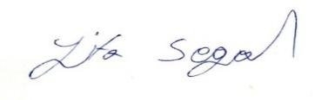

Yifa Segal, Esq.
Director
International Legal Forum

